DCN LAB 13

FAROOQ AHMAD
17L 4407
BEL 5B

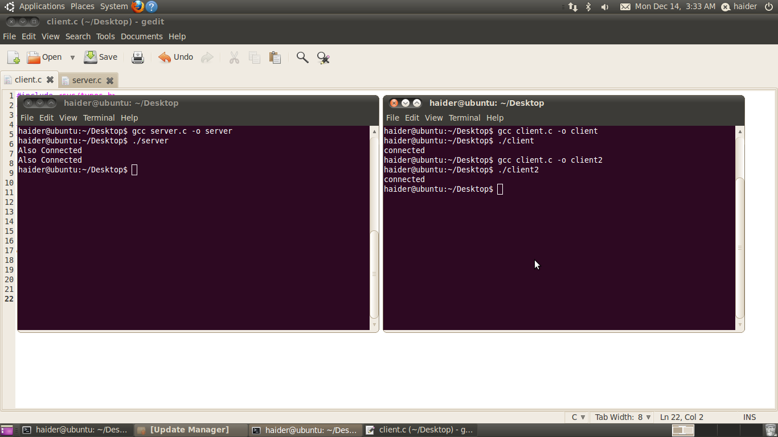

TASK 2
SERVER CODE
#include <sys/types.h>
#include<sys/socket.h>
#include<netinet/in.h>
#include<stdio.h>
#include <unistd.h>
#include <string.h>
int main()
{
int sd;
char* msg="connected";
char* username="fehmedc";
char* password="farooq";
char msg1[100];
char msg2[100];
struct sockaddr_in my_addr, client_addr;
my_addr.sin_family=AF_INET;
my_addr.sin_port=htons(4999);
my_addr.sin_addr.s_addr=inet_addr("127.0.0.1");
sd=socket(AF_INET,SOCK_STREAM,0);
bind(sd,(struct sockaddr *) &my_addr,sizeof(struct
sockaddr_in));
listen(sd,15);

int size=sizeof(struct sockaddr);
int new_sd=accept(sd,(struct sockaddr*)&client_addr,&size);
send(new_sd, "Enter Username",100,0);
recv(new_sd,msg1,100,0);
printf("%s%s","Username is ",msg1);
send(new_sd, "Enter Password",100,0);
recv(new_sd,msg2,100,0);
printf("%s%s\n","Password is ",msg2);
if(strcmp(msg1,"username")==0 && strcmp(msg2,"password")==0)
{
send(new_sd, msg,100,0);
recv(new_sd,msg1,100,0);
printf("%s\n",msg1);
}
else
{
send(new_sd, "error",100,0);
}
return 0;
}

CLIENT CODE
#include <sys/types.h>
#include<sys/socket.h>
#include<netinet/in.h>
#include<stdio.h>
#include <unistd.h>
#include <string.h>
int main()
{
int sd,sd1;
char msg[100];
char* msg1="Also Connected";
struct sockaddr_in server_addr;
server_addr.sin_family=AF_INET;
server_addr.sin_port=htons(4999);
server_addr.sin_addr.s_addr=inet_addr("127.0.0.1");
sd=socket(AF_INET,SOCK_STREAM,0);

connect(sd,(struct sockaddr*)
&server_addr,sizeof(struct sockaddr));
recv(sd,msg,100,0);
printf("%s\n",msg);
fgets(msg, 10, stdin);
send(sd, msg,100,0);
recv(sd,msg,100,0);
printf("%s\n",msg);
fgets(msg, 10, stdin);
send(sd, msg,100,0);
recv(sd,msg,100,0);
if(strcmp(msg,"connected")==0)
{
printf("%s\n",msg);
send(sd, msg1,100,0);
}
else
{
send(sd, "error",100,0);
}
return 0;
}

